Using Quizlet to Create Flashcards
- Open a Web browser to http://quizlet.com.
- Select “Sign Up” to create an account.
- Select “Create.”
- Enter a title and description (optional) for the set.

- Select the language for both the terms and definitions – English / English.
- Type in words/terms and definitions, or import words and definitions by selecting “Import” and then copying and pasting words/terms and definitions in the provided field and telling Quizlet what format you used to create the list.
- To view Quizlet lists submitted by others, type a search word into the Search field in the header and select the search/magnifying glass icon. To use any user-submitted definitions, select the title of the list. It can be copied and edited, or just added to your class.

- To use images, select the image icon. Select an image. Note: You need a paid teacher subscription to upload your own images, record your own voice, and manage a class with the ability to view individual students’ progress ($25/year).
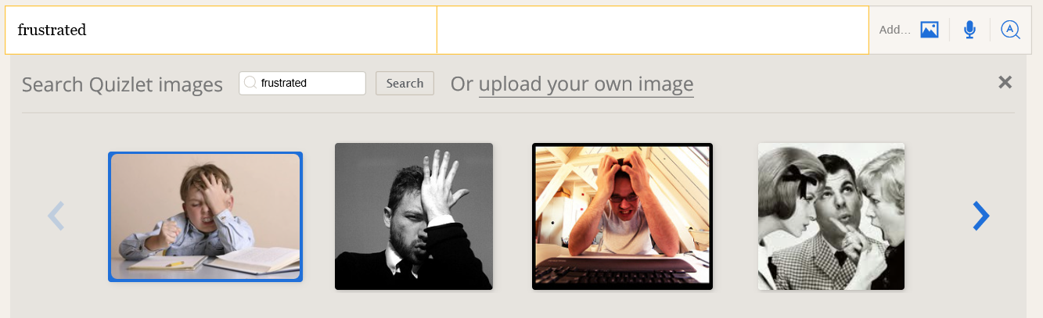

- Audio will play automatically for all words entered. Adding your own audio requires an upgrade to a paid teacher’s subscription. See https://quizlet.com/upgrade/teacher?source=header_teacher
- Add more rows, as needed, by clicking the [+].
- Save by selecting “Create.”
- Share a set by selecting “Share” in the top right under “Tools.” Select a social networking site, e-mail, or get the direct link.
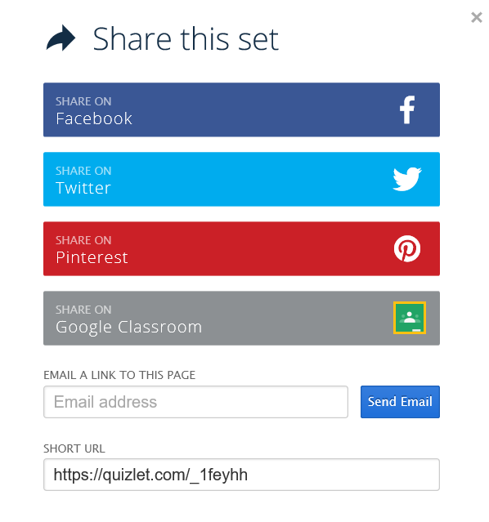
Edit a set:
- Log in and select the drop-down arrow next to your login name (top right corner) and select “Your Study Sets.”
- Select the title for a set and then choose “Edit” (pencil) icon.
- Make changes, add new terms, and select “Done” to save when finished.

Embed individual activities on a Web page:
  - When logged in, select a study set from the dashboard.
  - Select the “More…” icon.
  - Select “Embed.”
  - From the drop-down arrow, select the activity you want to embed.
  - Copy the HTML code for the activity you want to embed.
  - In the Web page, select the edit HTML option.
  - In the pop-up window, paste ([Ctrl] + [V]) the HTML code.
  - Click “Insert.”
  - Select “Submit.”
See the Embed Quizlet video tutorial at http://quizlet.com/faqs/faq-can-i-embedquizlet-on-my-website/.

Print flashcards
- When logged in, select a study set from the dashboard.
- Select the … (More) icon.
- Select the “Print” icon.
- Choose a Mode (table, glossary, index cards, etc.).
- Select “Open PDF” and print.

Print tests
- When logged in, select a study set.
- Select “Test” at the top.
- Select “Options” in the bottom left. Choose question types and number of terms to include and then select “Create New Test.”
- Select the “Print Test” button and print.
See the Teachers Page for ideas on using the site at http://quizlet.com/teachers.
For how-to instructions see the Quizlet Help page at http://quizlet.com/help, which has helpful screenshots, answers to questions, and video tutorials.
Mobile Apps Available for Apple and Android products http://quizlet.com/mobile.

